PROJECT REPORT TEMPLATE

ESTIMATION OF BUSINESS EXPENSES

1. INTRODUCTION
   1. Over view

India's agricultural sector has shown consistent growth over these years, with increased production of various crops. India has emerged as a major exporter of agricultural products, including rice, wheat, spices, and horticultural produce, contributing to the country's economy.

* 1. Purpose

To assess the effectiveness of agricultural policies, subsidies, and initiatives implemented by the Indian government during this period in achieving food security and promoting the agricultural sector's growth.

1. Problem definition and design thinking

2.1 Empathy map

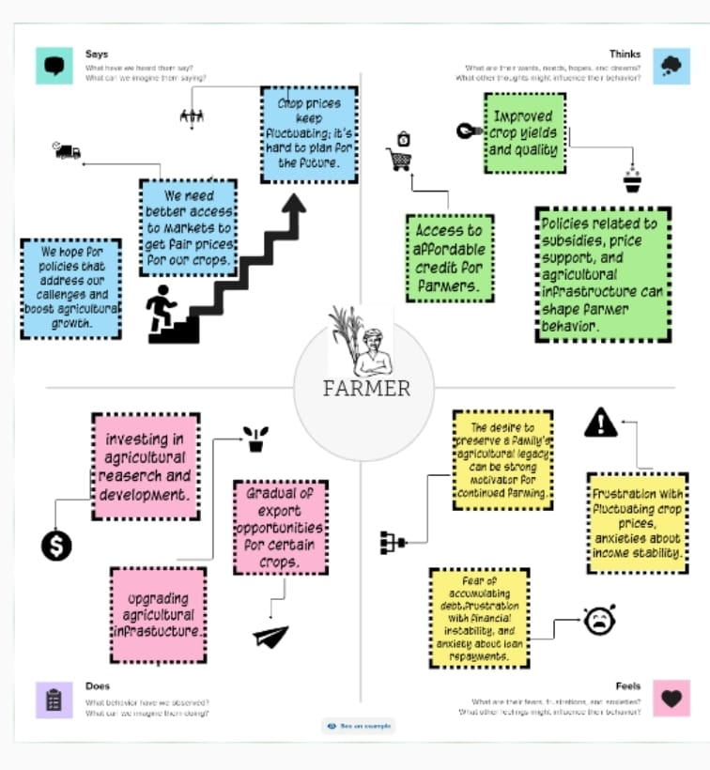

2.2 Brain stroming

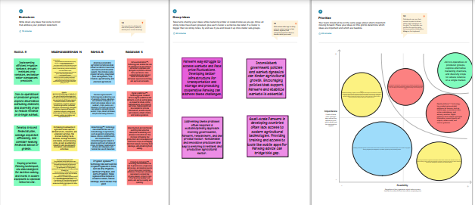

1. RESULT
2. Dashboard 1

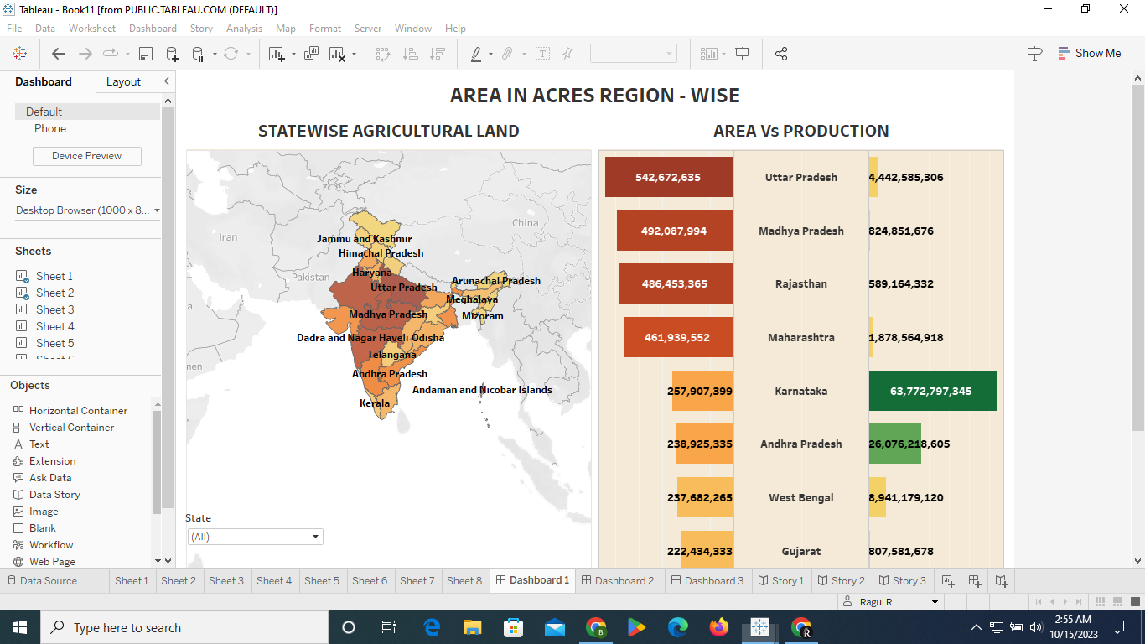

1. Dashboard 2

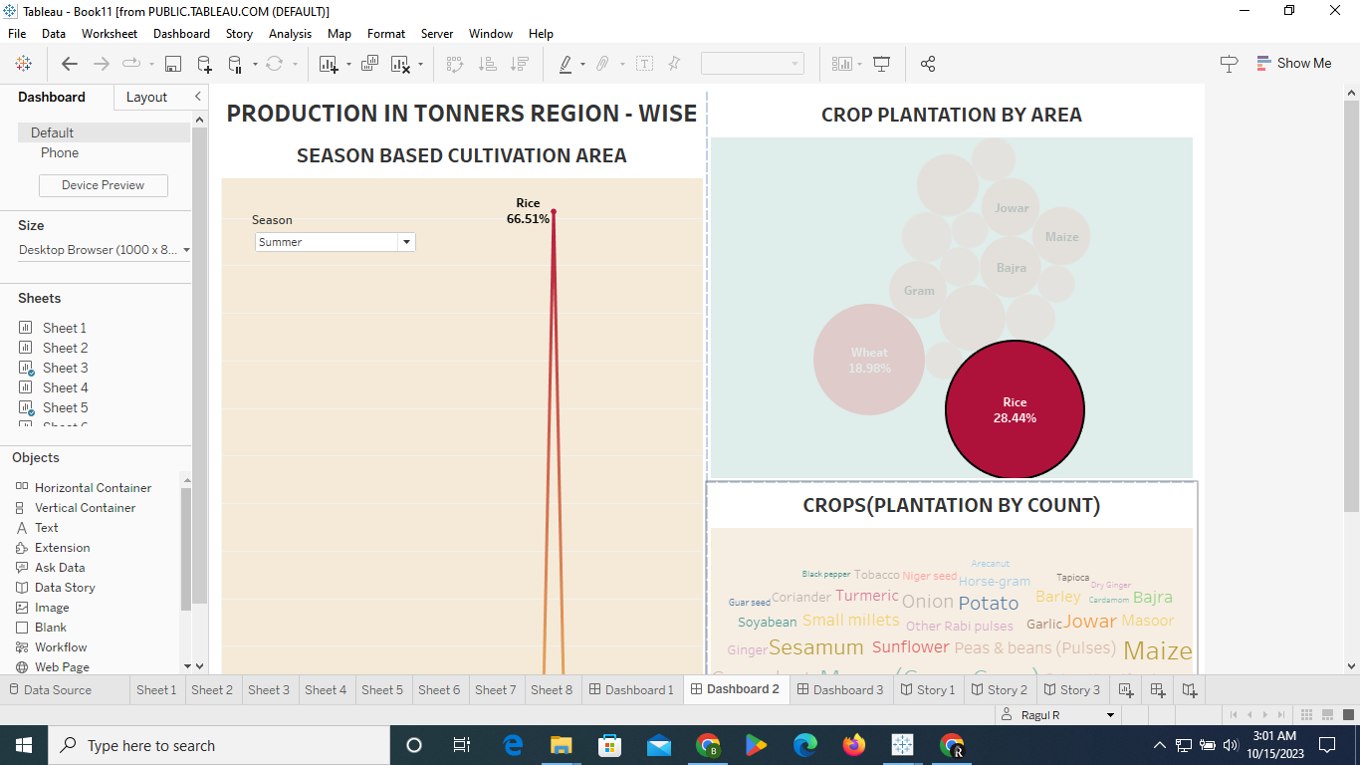

3)Dashboard 3

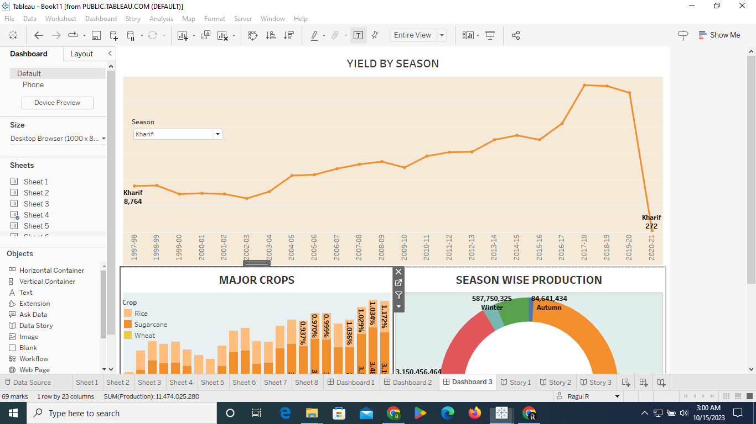

1. Story 1

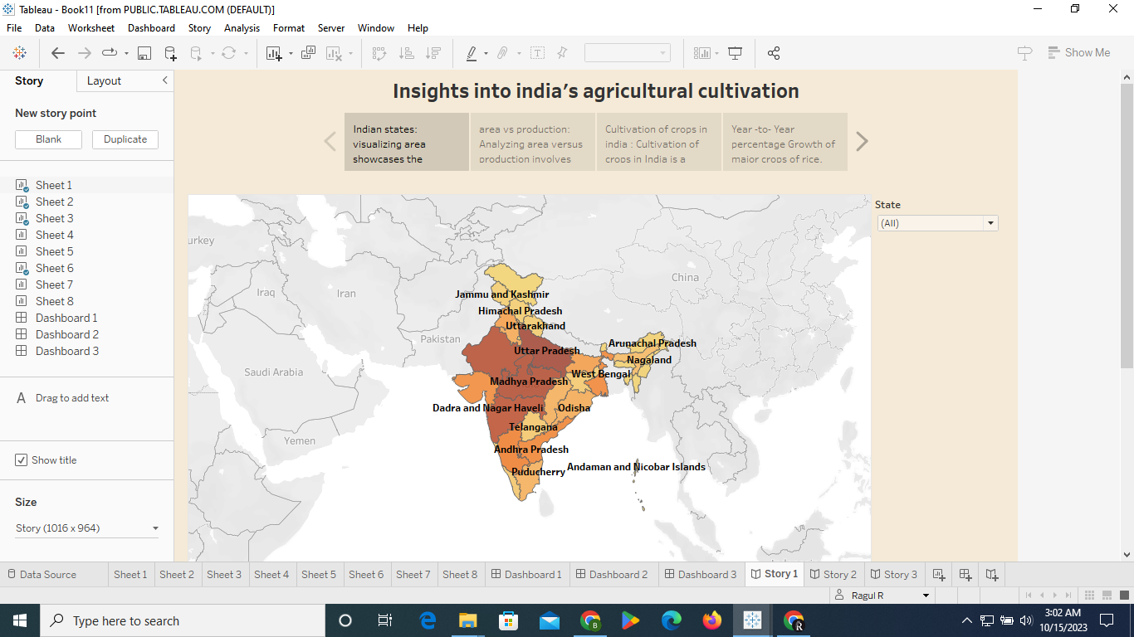

1. Story 2

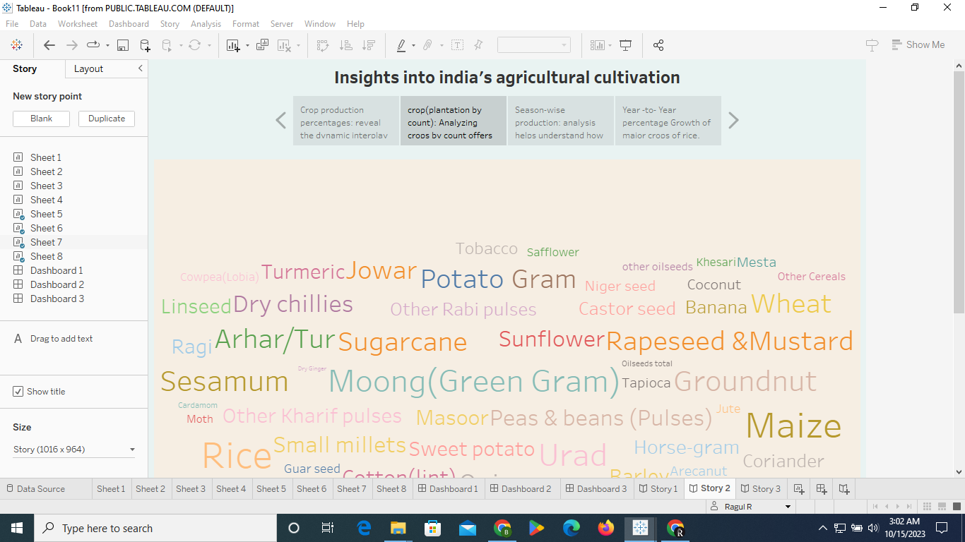

1. Advantage & Disagvantage

Advantage

Examining crop production data over this period provides a historical perspective on how India's agriculture has evolved. This can help in understanding trends and changes in crop production. It helps in identifying crops or regions where production has significantly increased, showcasing success stories and potential strategies for replication.

Disadvantage

Crop production data alone may not provide a complete picture of the agricultural sector. Factors like weather conditions, soil health, and market dynamics also play a crucial role. India's diverse agro-climatic zones result in significant regional variations. A national-level analysis may overlook these nuances.

1. Conclusion

India has witnessed a diversification in crops, with an emphasis on high-value cash crops such as fruits, vegetables, and oilseeds. This diversification aligns with changing dietary preferences and market demands. While increased production is a positive sign, it has raised concerns about the environmental impact, including soil degradation and excessive use of agrochemicals. Sustainable agricultural practices are becoming increasingly important.

1. Future scope

Leverage big data and analytics to make more informed decisions regarding crop selection, resource allocation, and risk management in agriculture. Explore opportunities for agricultural exports and import substitutions, aligning with global market trends.